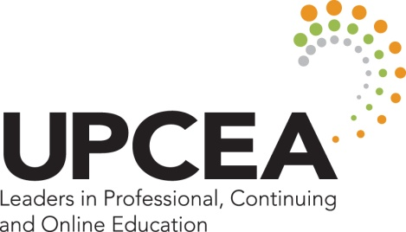

2017 UPCEA 102nd Annual Conference Leadership Meeting Schedule

Tuesday, March 21, 2017
10:30-11:30 AM 2016-17 and 2017-18 Executive Committees of the UPCEA Board of Directors
12:30-1:00 PM 2016-17 and 2017-18 UPCEA Board of Directors Lunch, Mayfair
1:00-3:45 PM 2016-17 and 2017-18 UPCEA Board of Directors, Mayfair
4:15-5:00 PM 2017 and 2018 Annual Conference Advisory Committees, Illinois
6:00-7:30 PM UPCEA Volunteer Leadership and Institutional Representative Reception, Chicago Promenade

Wednesday, March 22, 2017
8:30-9:30 AM 2016-17 and 2017-18 Regional Cabinets (Current + Incoming Regional Board Reps), Colorado
8:30-9:30 AM 2016-17 and 2017-18 Network Senates (Current + Incoming Network Chairs), Missouri
8:30-9:30 AM 2016-17 and 2017-18 Membership Committees (Current + Incoming Regional Membership Coordinators), Mississippi
9:30-9:45 AM Leadership Meeting Coffee Break, 2nd Floor Foyer
9:45-11:00 AM 2016-17 and 2017-18 Network Leadership Teams and Regional Councils (locations forthcoming)
- International Network Leadership Team, Mayfair
- Marketing, Enrollment, and Student Services Network Leadership Team, Erie
- Online Leadership and Administration Network Leadership Team, Huron
- Outreach, Engagement, and Economic Development Network Leadership Team, Michigan A
- Program Innovation Network Leadership Team, Michigan B
- Business and Operations Network Steering Committee, Mayfair
- Central Regional Council, Missouri
- Mid-Atlantic Regional Council, Ohio
- New England Regional Council, Ontario
- South Regional Council, Mississippi
- West Regional Council, Colorado

11:15-12:00 PM UPCEA Center for Online Leadership Advisory Council, Illinois Boardroom
11:15-12:00 PM Newcomer’s Orientation and “Conference Buddy” Introductions, Superior AB
11:30-12:45 PM UPCEA Past Presidents’ Lunch, Fountainview
12:00- 1:30 PM All Annual Conference Attendee Welcome Lunch and Opening General Session, Ballroom

Thursday, March 23, 2017
7:15-8:00 AM Editorial Board (tentative), Illinois

Friday, March 24, 2017
8:30-9:30 AM Corporate Advisory Committee, Illinois

